Chapter 8, Solution 70.

The schematic is shown below.

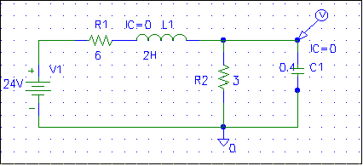

After the circuit is saved and simulated, we obtain the capacitor voltage v(t) as shown below.

